CALL FOR SUBMISSIONS:
Community engagement for inclusive rural transformation and gender equality
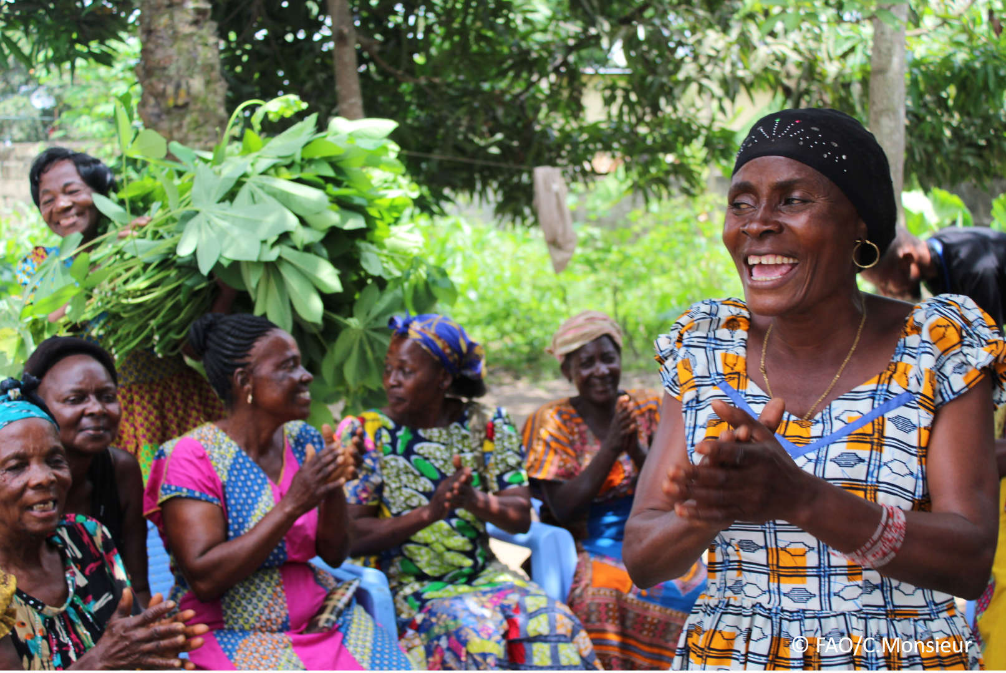
The objective of this call for submissions is to collect good practices, experiences, and lessons learnt on the use of community engagement for inclusive rural transformation and gender equality. The initiative, organized by the Rural Transformation and Gender Equality Division (ESP), seeks to gather insights from a diverse range of contributors, both within FAO and from external stakeholders. Its goal is to share knowledge, foster learning, and guide the scaling up of community engagement and community-led collective action to leave no one behind. The call builds on FAO's past efforts in this area, such as the Community Engagement Days series of webinars.
The call for submissions is open until 27 November 2024.

How to take part in this call for submissions:
To take part in this Call for submissions, please register to the FSN Forum, if you are not yet a member, or “sign in” to your account. Please review the topic note to understand the criteria we are considering for this call. If you wish to learn more about community engagement, you may refer to the background document. Once you have completed this submission template, upload it in the box “Post your contribution” on the call webpage, or, alternatively, send it to fsn-moderator@fao.org.
Please keep the length of submissions limited to 1,500 words and feel also free to attach relevant supporting materials.

Template for submissions

Contact person | Name: Thobela Nkukwana  Organization/Unit: University of Pretoria  Country: South Africa  Email address: thobela.nkukwana@up.ac.za
Name/title of the good practice | Small-scale poultry production scheme using recording, analysis and feedback sessions
Where is the good practice taking place? (Multiple selection allowed) | ☐ Europe and Central Asia  ☐ Latin America and the Caribbean  ☐ North Africa and Near East  ☒ Sub-Saharan Africa  ☐ Asia and the Pacific  ☐ North America  ☐ Global
Affiliation | ☐ Farmer and producer organizations  ☐ Trade Union  ☐ Informal community-based, farmer-based or self-help group  ☒ Research and academia  ☒ Government  ☐ Local/traditional authorities  ☐ Private Sector  ☐ Civil Society Organization  ☐ Intergovernmental Organization (e.g. UN system, World Bank)  ☐ Resource Partner/Donor  ☐ Other (please specify)
In which sector(s) and context (s) have you used this community engagement good practice? (Multiple selections allowed) | ☐ Education  ☐ Health and Sanitation  ☒ Food production in agrifood systems (please also tick the sub-categories)  ☐ Crop cultivation  ☐ Fisheries and aquaculture production  ☒ Livestock  ☐ Forestry  ☐ Agroforestry  ☐ Horticulture  ☐ Apiculture (beekeeping)  ☐ Agroecology and sustainable farming practices  ☐ Soil and water management  ☐ Other: ____________  ☐ Post-production in agrifood systems (please also tick the sub-categories)  ☐ Processing and value addition  ☐ Marketing and retailing  ☐ Transporting  ☐ Food loss and waste  ☒ Packaging  ☒ Storage  ☒ Distribution  ☐ Other _________  ☒ Gender Equality  ☐ Climate Action  ☐ Citizenship and Governance  ☐ Social Protection  ☐ Humanitarian and protracted crisis  ☐ Conflict resolution, peace and resilience  ☐ Digital innovation  ☐ Other sector (please specify) _________
Who are the financial partners supporting this good practice, if applicable? | The Department of Agriculture, Land Reform and Rural Development (DALRRD)
- In a few sentences, summarize your community engagement good practice.
Encourage farmers to keep production and costs incurred. They send these to the production scientist to analyse and prepare reports as feedback to individual farmers. The feedback includes coaching and encourage adoption of good practices.
- What problem(s) or challenge(s) does your good practice aim to address through community engagement?
The challenge is low profitability and sustainability of small-scale poultry farming.
- Describe your good practice in more detail. Include the main guiding principles, the desired changes or outcomes you aim to achieve (Theory of Change), and the key phases of implementation.
Farmers are exposed to profit thinking framework of farming broiler and layers under small-scale production systems. The records that they keep provide details about all profit drivers in farming broilers and layers. Analysis of the records reveal the problematic areas to focus on to improve profitability. Then farmers are assisted to develop action plans to address each focus area.
- Who are the key actors and stakeholders involved in the design and implementation of the good practice, and what are their respective roles? Consider local partners, government, local authorities, community radios, civil society, research, the private sector, etc.
Stakeholders involved:
- The Department of Agriculture, Land Reform and Rural Development (DALRRD) – Data collection; capturing and analysis; organising training workshops; training the trainer (agricultural advisors) on data collection
- South African Poultry Association (SAPA) – to be roped in for training expertise
- Provincial departments of agriculture – assist with farmer mobilisation
- Agricultural Research Council (ARC) – data capturing and recording
- National Agricultural Marketing Council (NAMC) – data analysis and reporting
- Small-scale farmers – collect data and implement action plans

- How does your intervention ensure inclusivity and equal and meaningful participation within the community?
Describe how your intervention includes and engages different groups within the community. Consider aspects like gender, age, ethnicity, disability status, livelihoods, and other specific conditions (e.g., people living in prolonged crisis, migrants, refugees). Explain how your intervention engages diverse segments of the rural community. Highlight the specific actions or strategies you use to reach these groups. If applicable, mention if your intervention uses specific approaches such as gender-responsive, gender-transformative, intersectionality, or other methods to ensure inclusivity and gender equality.
- For the purpose of participation in the scheme, it was decided to classify participating farmers into the following categories:
Subsistence farmers — 0 to 50 chickens (Male 3, female 8)
Developing farmers — 50 to 40 000 chickens (Male 129, Female 181)
Small Scale farmers — 40 000 to 120 000 (Male 11, Female 17)
Commercial farmers — 120 000 + (Male 1, Female 0)
Out of a total of 350 participants, 206 were females and only 144 were males. This ratio indicates the consideration that is been given to the training of female farmer participants and the important role they play in contributing to food security.
- By using community engagement, what results and impacts have your good practice achieved?

Please provide specific examples and evidence demonstrating the effectiveness of your intervention, focusing on both qualitative and quantitative outcomes related to livelihoods and well-being improvements.
Through these community engagements, most small-scale farmers developed interest in participating in the scheme, which leads to increase in their income and improvement in their livelihoods. This also leads to resilience in their livelihood system. These small steps are contributing to the growth of local economies through improved productivity and technical knowledge in management practices. These impacts were achieved:
- Through farmer feedback sessions.
During farmer mobilizations, it was found that the skills and knowledge of the farmers is at different levels. Some farmers lack both practical skills and knowledge, while others need to be capacitated in only one aspect. Different topics revealed from analyzed data are covered through presentations and demonstration sessions.
- Through exposure to the biennial international poultry conference (Avi-Africa Conference and Exhibition) that attracts key stakeholders in the poultry production sector regionally and internationally.
Few of the best farmers are then exposed to the Avi-Africa Conference and Exhibition, a biennial international event organized by SAPA, as an incentive. This exposure is valued as farmers get an opportunity to know more about the poultry industry, meet the companies behind poultry production (breeders, processors, packaging, marketing, equipment and pharmaceutical) all under one roof.

- Among these results, has the good practice led to improvements in terms of gender equality, women’s empowerment, and/or social inclusion?
Describe the behavioral changes in terms of gender that the good practice promotes, emphasizing agency, leadership, and participation in local governance. Include efforts to challenge discriminatory norms and unequal power dynamics. Highlight also how the intervention has supported the well-being (including psychological resilience) of marginalized groups and enhanced their inclusion and participation in decision-making processes.
The majority of our farmers operate in the subsistence and developing categories, and are mostly women. Since DAP started with the implementation of the capacity building initiative, about:
- 34.6% of the farmers have either increased their production or made improvement in their management practices. However, some have shown no change, limited by availability of resources like houses and equipment to expand their businesses.
- 32% have reported a decrease in mortality, which they say is attributed to the intervention (feedback sessions, conference and farmer information days) brought about by DAP. The decrease in mortality rate was also due to exposure to new technologies and the correct use of vaccines. Collectively, the feedback sessions, conference attendance and the farmer information days play a crucial role in introducing new technology.
- 35.7% of the farmers have access to reliable market, but the market demand is far more than what they can supply. Available markets include contracts with retail shops, contracts with public hospitals, some prisons, communities, pension pay points, and school feeding schemes. DAP believes that the knowledge gained is enabling farmers to expand their businesses, which can lead to job creation if businesses expand and remain operating sustainably.
- 70.3% of participants reported a contribution to job creation on both permanent and temporary staff, mostly being women. To sustain these improvements, continuous support and intervention by all stakeholders is necessary where and when necessary. The knowledge gained through conference attendance and exposure has many farmers wishing for another opportunity. DAP has since established feedback sessions for individual and groups farmers. for farmers who are within close proximity to periodically meet to share knowledge and experiences among each other.
- The attrition rate has dropped due to the format of the support (recording, analysis, feedback sessions, conference attendance and information days) provided by DAP.
- What key challenges did you encounter while implementing the community engagement activities, and how did you address them?
Include any resistance from communities, pushback, or issues related to unequal power dynamics, if applicable.
Although the methodology is optimal in capacitating farmers, the success and sustainability of these farmers depend on other external factors, namely:
- Access to finance,
- Power supply due to loadshedding,
- Water availability and quality,
- Cost of production inputs, and
- Impact of disease outbreaks, especially Avian Influenza which led to shortage of fertilized eggs, therefore limited access to day old chicks and point-of-lay pullets.
- Covid-19 which led to economic hardships and job losses.
- Limited access to market
- Reluctance by small-scale farmers in adopting proposed interventions. When farmers learn from each other, they are more likely to adopt a new technology or proposed intervention.
- Other challenges include lack of financial support, location of abattoirs and hatcheries far from farmers, and occurrence of diseases. The newly established Poultry Disease Management Agency (PDMA) under SAPA is working very hard to capacitate state veterinarians working with poultry. This will ensure that farmers get relevant solutions to challenges relating to poultry diseases. As SAPA is implementing the capacity building for DAP, the PDMA will become very handy and will work very closely with the implementing agent.
- What are the key lesson learned from your community engagement good practice?
- That purposive selection of farmers who are committed to farming and are willing to gain knowledge and skills is paramount.
- Future interventions should focus directly on individual small-scale farmers and be intentional in encouraging them to record and use records analysis to improve their poultry production.
- Profiling of small-scale farmers according to their business acumen was considered critical to help design different and effective support intervention. The questionnaire for profiling was developed.
- Has this practice been replicated in the same context or in different contexts?
What are the required conditions to replicate and adapt the practice in another context/geographical area?
An Intervention Training Manual was developed to guide experimentation and facilitate replication across the provinces. DAP is making a concerted effort to ensure that PDAs take over the intervention strategies as deemed fit for each province. Some provinces are ecologically suited to produce laying hens, while others thrive better in the production of broilers. Climatic conditions in each province also play a role in poultry productivity so the methodology help counter challenges due to ecological and climatic conditions.

The following are some of the aspects that should be considered before any intervention is implemented:
- Training of trainers, especially agricultural advisors or extension officers who work closely with farmers. Monitoring and evaluation is key, so trained practitioners in the field are of critical importance.
- Purposeful identification and selection of farmers invested in the farming system they are involved in, as well as key stakeholders to optimise the intended intervention.
- Conduct environment impact assessment on each farm in case farmers wish to expand their businesses. Some farms have limited access to water, roads and power stations.
- Ensure that provincial offices commit to working with and providing technical assistance to farmers.
- Private-public sector collaborations should be encouraged in creating awareness, as well as transfer of skills and knowledge.
- Encourage involvement of youth and women in agricultural activities and teach them the importance of producing food at household and community level.
- Advocate for teaching and learning of subjects that lead to acquiring higher education training in agriculture. Many rural schools are not aware that learners require mathematics and natural sciences to pursue a qualification in agricultural sciences.

- How sustainable are the results achieved by this good practice?
Describe the key elements that need to be in place to make the initiative sustainable, including enabling environment (legal and policy frameworks and institutions), local ownership, accountability, etc.
- Once farmers have been given feedback on how to manage poultry production and troubleshoot challenges that impede profitability and sustainability.
- Farmers participating in the scheme have started to realize and appreciate the intervention by the DALRRD as it is bearing fruits in the form of profit. For as long as they continue to derive positive benefits, the good practices can be sustainable.
- Poultry production continues to be seen as a pathway out of poverty. As the cheapest source of protein, poultry will remain the main commodity that small-scale farmers look up to for income generation and food security. Now that farmers are aware of the business side of their poultry production systems, they are more focused on profit and managing their poultry as a business.
- Through the intervention, other farmers have started grouping themselves to manage the placement and marketing of their produce. They have developed social media platform to share information on when, where product is ready for market. In this way, they can direct their client on where to source their preferred meat-chicken.

- Based on the conversations FAO held during the Community Engagement days, a definition of community engagement for empowerment was proposed:

“Community engagement for empowerment and community-led collective action can be defined as an inclusive and participatory process that enables community members to become active agents of change in decisions affecting their lives, health, and environment. This process develops their capacity to achieve sustainable outcomes for improved rural livelihoods. Embracing a rights-based approach, it prioritizes the agency and participation of all community members, regardless of gender identity, sexual orientation, age, ethnicity, caste, socioeconomic status, political affiliation, migration status, or ability/disability. Indeed, inclusive approaches recognize the complexities of overlapping marginalization and discrimination that can exclude different community members from decision-making processes and implement strategies to foster their participation, agency and empowerment.”

We invite you to contribute to this definition. What would you add or change? Please share your thoughts, suggestions, and any additional elements you believe are crucial for a comprehensive understanding of community engagement approaches aimed at community-led collective action for inclusive rural transformation, people’s empowerment and gender equality.
We consider community engagement as partnership brokerage. In this brokerage, we consider community, ourselves and other stakeholders’ interests in defining our partnership. We consider each other equals in knowledge and experiences that lead to successful implementation of interventions.

- Based on your experience, what gaps or areas for improvement still need to be addressed in the field of community engagement?
We need methodologies that help define interests amongst partners and the community, as well as the focusing frameworks that lead to shared goals.
- What do you think is FAO's role in the field of community engagement? How can FAO support and enhance interventions like yours, if applicable? Consider aspects such as policy advocacy, capacity development, funding, technical assistance, knowledge production and sharing, and fostering partnerships.
FAO can play a role of supporting refinement of community engagement approaches and skills in partnership brokerage. Moreover, FAO can help with proper evaluation of the effectiveness of the proposed methodologies of community engagement. Once validated, then they can support policy advocacy, capacity building and upscale the use of the methodology.

Link(s) to specific references about your good practice (e.g., reports, communication products, videos, articles) | Please include attachment(s) or add here link(s) to documents/videos/podcasts/other with specific references.

The call for submissions is directly aligned with the thematic components of collective action within FAO's Programme Priority Areas (PPAs), specifically Better Life 1 (Gender Equality and Rural Women’s Empowerment), Better Life 2 (Inclusive Rural Transformation) and Better Life 3 (Agriculture and Food Emergencies).

